**Intro**

This project is based on Assistive technology (AT). Assistive technology is any item, piece of equipment, software program, or product system that is used to increase, maintain, or improve the functional capabilities of individuals with disabilities. It helps people who have difficulty speaking, typing, writing, remembering, pointing, seeing, hearing, learning, walking, and several other conditions. Different disabilities require different assistive technologies.

Assistive technology promotes greater independence by enabling people to perform tasks they were formerly unable to accomplish, or had great difficulty accomplishing, by providing enhancements to, or changing methods of interacting with the technology needed to accomplish such tasks. For example, wheelchairs provide independent mobility for those who cannot walk, while assistive eating devices can enable people who cannot feed themselves to do so. Due to assistive technology, people with disabilities have an opportunity of a more positive and easy-going lifestyle.

Overall, assistive technology aims to allow people with disabilities to "participate more fully in all aspects of life (home, school, and community)" and increases their

opportunities for "education, social interactions, and potential for meaningful employment".

**Purpose**

The main purpose of this project is to allow people with disabilities to participate more fully in all aspects of life such as home, school, and their surrounding community and increases their opportunities for education, social interactions, and potential for meaningful employment. Quadriplegia is one of the cases where the patient is unable to move any part of his body below the neck. Complex and expensive interfaces are used for solving this issue. One effective solution for this condition is Tongue Drive Assistive System (TDAS). In TDAS, the tongue movement is an input to the processor. In previous solutions of TDAS, patients were necessitated to undergo surgery. In order to eliminate the process of surgery, this project presents a unique approach where tongue movements are sensed from externally connected wireless head band to control devices and to communicate with people. The proposed idea is more hygienic, simple and can perform a greater number of commands as compared to other existing assistive technology solutions.

Sub topic – **Some of the older assistive technologies for the Disabled :-**

***SIP ‘N’ PUFF***

***BCI***

**Comparision**

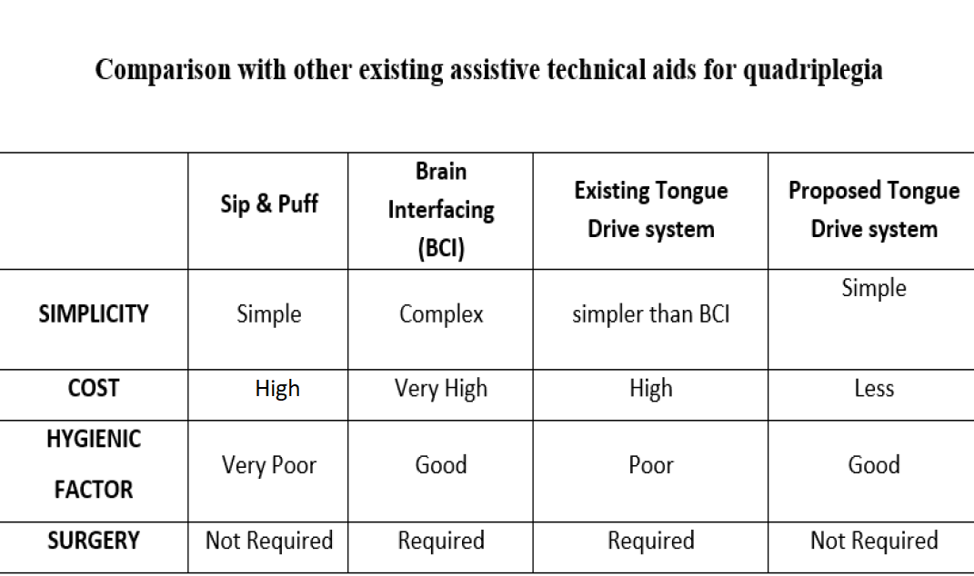

**Requirements**

**Hardware Requirements:**

**Equipment for wheelchair:**

* Arduino Uno
* SD Card module
* DC motor
* Battery
* RF-transmitter
* RF-Receiver
* H-Bridge
* Push Buttons
* Ultrasonic Sensors
* Buzzer
* Speakers

**Equipment for Obstacle sensing:**

* Arduino Uno
* Ultrasonic Sensor
* Buzzer

**Equipment for Voice-command Speaker:**

* Speaker
* Arduino Uno
* SD Card Module
* Push Buttons

**Equipments for movement of wheelchair:**

* Arduino Uno
* Push Buttons
* DC Motor
* Battery

**Interfacing requirements:**

* Piezo Buzzer
* Arduino Uno
* Resistor
* Jumper wires
* Breadboard

**3.2 Software Requirements:**

* Arduino IDE

**Methodology**

The working principle of this project is simple and effective. It can also be divided into two segments: Sensing the tongue movement externally from the head band and processing the input signal and matching it to the respective output.

In this proposed solution, there will be a head set which is to be worn by the user. The head band will contain four push buttons on either side of the cheek (refer figures). As the patient pushes the respective button with the aid of the tongue, it will be sensed by the headband. Based on the multiple combinations of the buttons pressed, the processor actuates the respective command’s output. The commands from the headset can be transmitted to the processor via wired or via wireless systems.  
This project works on two algorithms; one is to drive the powered wheel chair in all directions and the other to communicate to the people via speakers that are attached to the wheel chair. The system also has the feature of sensing the obstacles and taking that as a priority while executing other commands. In addition, pre-fed commands can be used to direct several other actions.

**Conclusion**

According to WHO, every year, around the world, between 250,000 and 500,000 people suffer a spinal cord injury (SCI). Owing to high costs of treatment and unaffordability, a vast majority is left with the disability. Not only are they wheel-chair bounded but are greatly independent on care-takers to carry out even minor tasks for themselves. Wheel-chairs enabled with assistive technology are highly priced and again unaffordable to much of this population. The project aims at building an assistive wheelchair that is not only affordable to masses but also includes multiple features that will help improve their conditions, reduce dependency and enhance quality of living.

